A50-AM,S-Colombia-Tairona-Gold Figurine-Gualchováng Holding Two Batons-1000-1500 CE

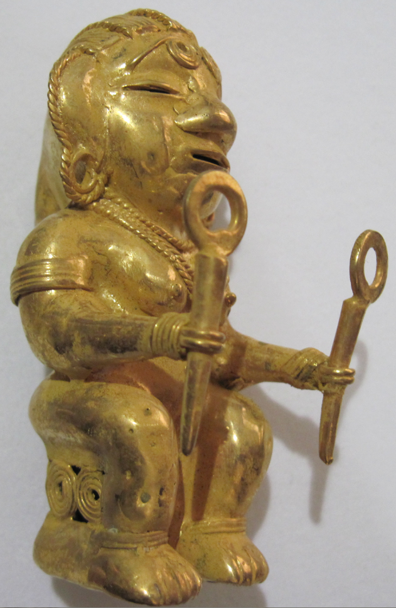 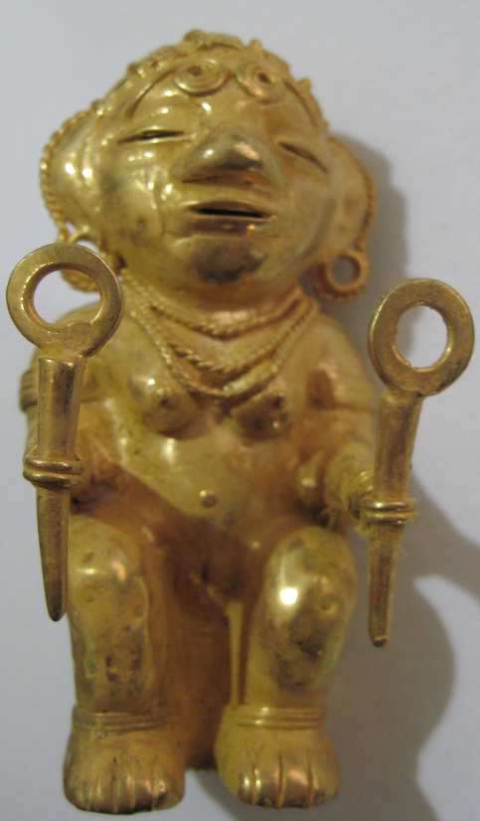 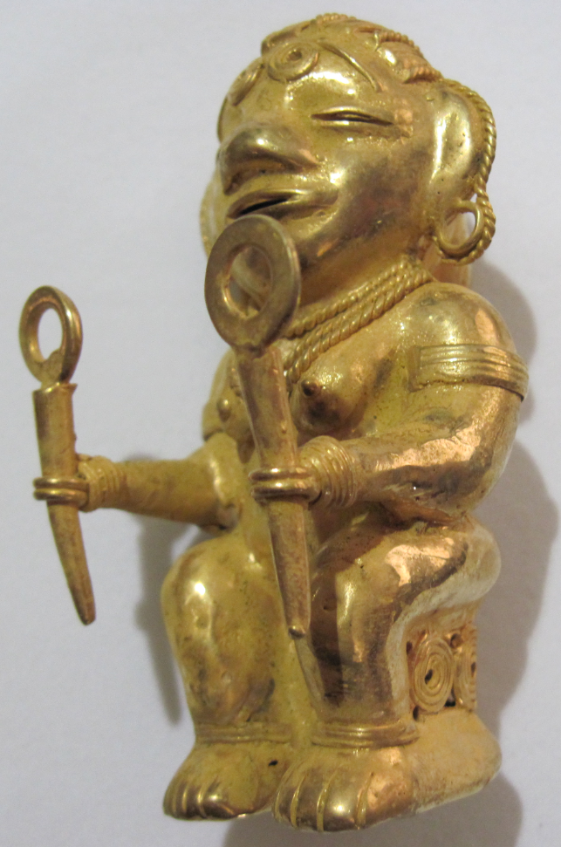 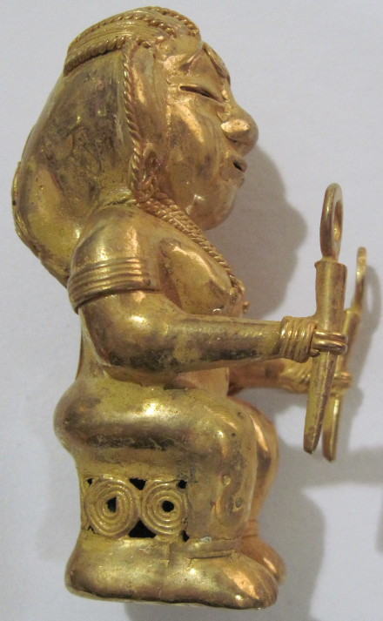 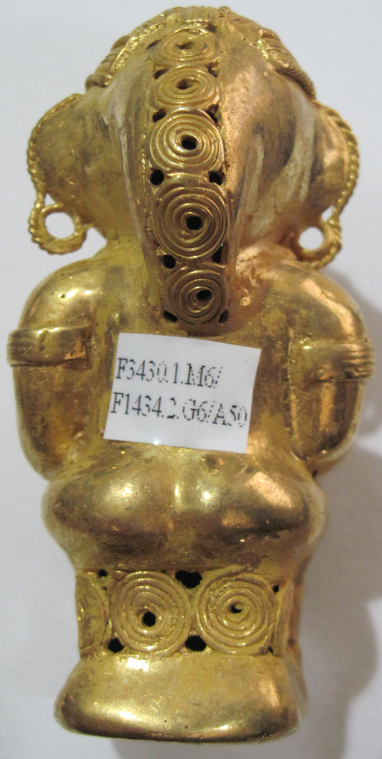 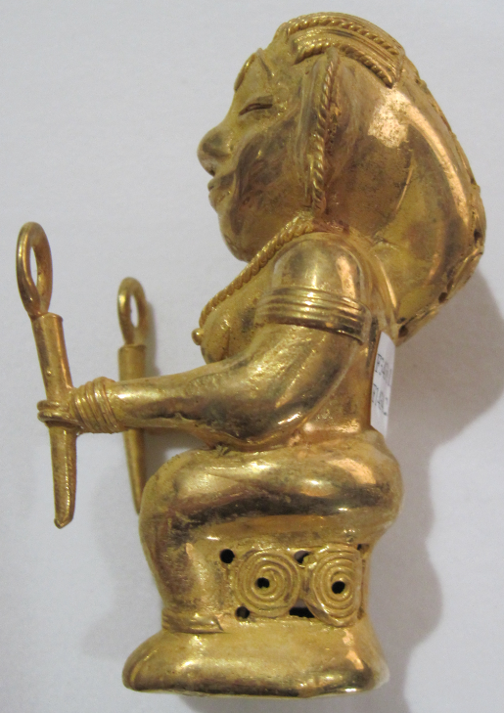

Figs. 1-4. Colombia-Tairona-Gold Figurine-Gualchováng Holding Two Batons-1000-1500 CE

**Case no.: 7**

**Accession Number: A50**

**Formal Label:** Colombia-Tairona-Gold Figurine-Gualchováng Holding Two Batons-1000-1500 CE

**Display Description:** *Gualchováng* in Tairona mythology is” the Mother of Every Thing and No Thing. She is pure Idea.”

This gold figurine of *Gualchováng* probably portrays her as *Bunkuane-ne-nulang* of the Sixth World, as she is holding creation batons probably for *Bunkua*-blue and *Bunkua*-black

The following myth procured from one of the Kogi *Mámas* in 2006 presents the Tairona World-View or *Weltanschauung* of Creation (translated after <https://sites.google.com/site/poesiaancestral/la-creacion>). These strictly memorized pieces are suggested to have been preserved for hundreds of years. In view of the Tairona process of becoming a *Máma* it has been maintained this may have been possible at least for its outline.

In the beginning was the sea.

Everything was dark.

No sun, no moon, no people, no animals, no plants.

Only sea everywhere.

Sea was Mother.

Mother was water and water was everywhere.

She was river, lagoon, ravine and sea.

She was everywhere.

In the beginning was only Mother.

Her name was *Gualchováng*, creator of all.

Mother was not people, or any Thing, or no Thing.

She was *Alúna*.

She was Idea -- the future.

She was thought and memory.

Mother existed only

In the depths, alone.

As Idea of the lower world.

When Mother existed, worlds and lands were only Idea.

Nine Worlds emerged which formed like this:

In the First World Mother was water and night.

It had not yet dawned.

Mother was named *Se-ne-Nulang*.

Father was named *Kata Ke-ne-ne-Nulang*.

Son named *Bunkua-sei*.

No people, or any Thing, or no Thing.

They were Ideas. They were spirit and thought.

That was the First World, the first place and the first Ideas.

Then another world was formed, the Second World.

Then there was a Father who was a jaguar.

But it was not a jaguar like an animal; it was a jaguar like a spirit.

Then another world was formed, the Third World.

People emerged, they were born of Mother.

But they had neither blood nor bones.

They moved like worms.

Then the Fourth World was formed.

Mother's name was *Sáyaganeya-yumáng*

Another Mother was *Disi-se-yuntaná*

Father was *Sai-taná*.

This Father was the first who knew the future.

He saw the people of our world.

And he was the first to know his body emerging,

Head, arms and legs emerging.

Then another world was formed, the Fifth World.

Mother was *Enkuane-ne-nuláng*.

No Things yet, but now the first shelter was formed,

Not with sticks, mud or straw, but as Idea, in spirit, nothing more.

Then emerged *Kashindúkua, Noana-se* and *Nánacu*.

Then emerged people, but they still lacked ears, eyes and noses.

They had only feet.

Then Mother told them to speak.

It was the first time people spoke,

But since they had no language yet, they said:

*Sai-sai-sai* ("night-night-night")

There were now five worlds.

Then the Sixth World was formed.

Mother was *Bunkuane-ne-nulang.*

Father was *Sai chaká*.

They were already forming a whole body

Head, arms and feet.

Then the workers of the World began to be born.

They were the first two: *Bunkua*-blue and *Bunkua*-black.

The World was divided into two parts on two sides:

The Blue and the Black,

And in each there were nine *Bankua-se*.

Those on the Left were all Blue

And those on the Right were all Black.

Then the Seventh World was formed.

Mother was *Ahunyika*.

The body still had no blood

But now blood was emerging.

Then the Eighth World was formed.

Mother was *Kenyajé*.

Father was *Ahuína-Katana*.

When this world was formed how could one live.

It was not yet complete. But almost.

Then water was still everywhere

It was not morning yet.

Then the Ninth World formed.

But Earth was not yet.

Morning was not yet.

**LC Classification:** F1434.2

**Date or Time Horizon:** 1000-1500 AD/CE

**Geographical Area:** Sierra Nevada de Santa Marta**, Colombia. Indigenous names are:** Kankuamo (*Umunukunu);* Kogi (*Gonawindua).*

**GPS Coordinates:** **10o57’N, 73 o 48’W**



Fig. 5. Map of Spanish Provinces in 1600. After <https://html2-f.scribdassets.com/5nmwqq7itc4aqx2e/images/6-a5a093175f.jpg>. Yellow place-holders mark the centers of the four Tairona cultures (in bold) as of 2017.

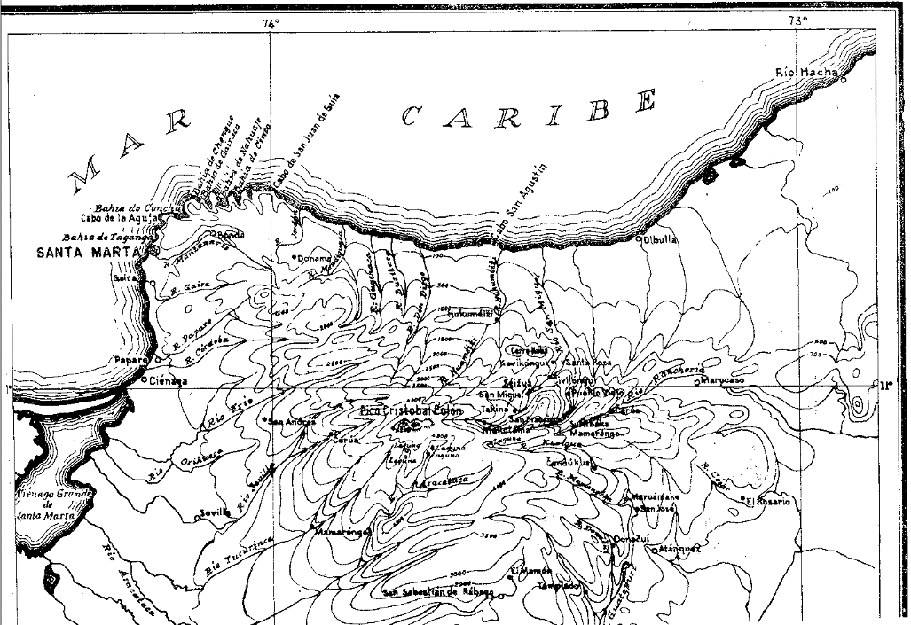

Fig. 6. Topographic map of the Sierra Nevada of NE Colombia. From Reichel-Dolmatoff 1950.

**Cultural Affiliation:** Tairona, Chibcha Language

**Medium:** Lost-wax cast of tumbaga, an alloy of gold and copper. Its surface was subsequently enriched by the depletion method, also known as *mise-en-couleur*.

**Dimensions:** H 87.94 mm, 3.46 in.

**Weight: 83 gm, 2 7/8 oz**

**Condition: original**

**Provenance:** Tairona villages

**Discussion:**

The pre-Tairona period is known as the Nahuange Period (Bischof 1968) and is based on the stratigraphy of jadeite objects and the dating of gold artifacts excavated from coastal sites ranging from cal. AD/CE 130 ± 40 to cal. AD/CE 480 ± 40 (Bray 2003:324) in small, isolated, non-hierarchical towns and buildings without stone foundations (Giraldo 2010:181). Beginning ca 450 AD/BC pressure from the Caribs in the Orinoco River Valley caused an ethno-linguistic group, the Taino, to advance from the Orinoco River Valley into the Lesser and Greater Antilles (Menhinick 1997). During this Carib expansion Nahuange descendants, the Tairona, migrated from the lower to the upper slopes of the Sierra Nevada de Santa Marta and assembled non-hierarchical towns with circular stone foundations which they connected by flagstone trails (Rogonzinski 2000; Allaire 1997; Basso 1977).

These trails continued a desire to maintain trade and exchange with neighboring areas that they had developed for precious gems such as greenstone beads of the variscite-group minerals from Gran Roque Island and Barquimeto (Acevedo et al. 2017).

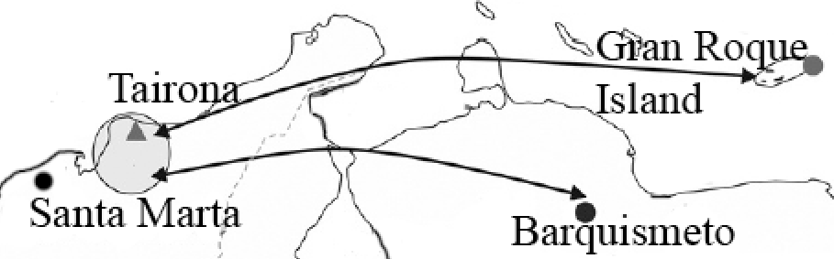

|__________| 300 km

Fig. 7. Map of Tairona trade routes from Gran Roque Island and Barquismeto. After Acevedo et al. 2016, fig. 7.

Tairona mythology, dating from their Nahuange predecessors whose dwellings lie below those of the Tairona (Acevedo 2016; Dever 2007), views the highest mountain, which the Spanish named “Pico Cristobal Colon” to negate its indigenous religious power but which the Kogi named it Gonawindua, the “Holy Mountain.” Similarly, the Spanish gave the mountain massif the name of a Catholic Saint to again deprive it of its indigenous religious power, “Sierra de Santa Marta,” but the Tairona preserve its original name, “the Heart of the World.” Tairona mythology teaches that they are "Elder Brothers" of humanity and that those not living in the “Heart of the World” are called "Younger Brothers," the Caribs from the Orinoco Valley and by extension the Spanish and all those apart from the Tairona and their descendants (Cadavid y Herrera 1985; Groot 1985; Langebaek 2003, 2005; Oyuela-Caycedo1986, 1987; Reichel-Dolmatoff 1997; Serje 1987; Wynn 1975). When the Spanish arrived in the sixteenth century their Conquistador leader, Rodrigo de Bastidas, as he initiated the building of the city of Santa Marta in 1525 had the following proclamation read out on the beach (Tairona 2015)

  “I assure you that with the help of God I will enter powerfully against you, and I will make war on you in every place and in every way that I can, and I will subject you to the yoke and obedience of the church and their highnesses, and I will take your persons and your women and your children, and I will make them slaves, and as such I will sell them, and dispose of them as their highnesses command: I will take your goods, and I will do you all the evils and harms which I can, just as to vassals who do not obey and do not want to receive their lord, resist him and contradict him. And I declare that the deaths and harms which arise from this will be your fault, and not that of their highnesses, nor mine, nor of the gentlemen who have come with me here.”

Only in 1965 did Colombian archaeologists uncover a previously unrecorded mountain trail of 1,200 steps in the rain forest on the slopes of Sierra Nevada de Santa Marta, which led to an ancient abandoned city (“Ciudad Perdida”; 11°02'22.9"N 73°55'33.8"W) where gold figurines and ceramic urns were later unearthed. Tairona descendants—the Arhuaco and the Kogi—re-called the site which they called “Teyuna” with its series of 169 terraces and several small circular plazas.

Within Teyuna the open, permeable system of unstructured staircases allowed all to participate in a visual and social equality in which the display of gold appurtenances and valued feather headdresses denoted symbols of potential social productiveness accessible to all members of Tairona society. This “open society” can be appreciated in the plot plan and side views of Teyuna’s main cluster of houses (see Fig. 8). Teyuna’s configuration emerged relatively late in the building sequence (ca 11-12th century AD/CE), following an incremental pattern as new areas were added to pre-existing ones by paved paths and staircases that allowed access to any compound from multiple directions thereby ensuring a continuous flow of people to and from any part of the village. Rectangular ceremonial structures excavated by John Alden Mason in 1921/1922 (Fig. 8, no. 52; Mason 1931, 1936) unearthed numerous fragments of double spouted ceramic urns for brewing corn beer, *chichi*.



Fig. 8. Double-spouted *chichi* vessel restored, after Mason 1931, plate CLXXI. Illustrating Great Mother Creator, Gaulcováng and Her children -- Lords of the Cosmos, Seokúkui and Seizankwa.

Artifacts inside these buildings and nearby residences suggest that these locations served as distributed repositories of valued ceremonial goods, such as stone batons and monolithic axes (as symbols of authority and power), winged pendants (used as tinklers suspended from the arms in dances), ceremonial gold bells, and beads (carnelian, jadeite, quartz).





Fig. 9. North End of Ciudad Perdida's Central sector (plot plan and side view) showing the rectangular ceremonial center (no. 52) and the overlaps of sequential construction with the altitudinal distances between terraces and subsidiary staircases connected to the main staircase. From drawings by Peter Kellett and Angela Uribe Kellett, 1984 (Uribe Tobon 1990). Today, however, many Kogi and Arhuaco villages have built waist-high stone walls to exclude non-Tairona peoples from entering.



Fig. 10. Sign posted on the entryway to an Arhuaco village stating “The entry of non-indigenous people is prohibited …”. From http://assets.survivalinternational.org/pictures/2021/img-2313_screen.jpg.

**Kogi**

Kogi philosophy is based on *aluna*, cosmic harmony. The Great Mother Creator, Gaulcováng (from gau – “to create”), has many manifestations, such as ***Hába Guxsénse***, “Mother of the Eternal Fire,” and Málkwa-yang, “Mother of the Knowledge of Weaving.” Her children -- Lords of the Cosmos, Seokúkui and Seizankwa -- carry Gaulcováng’s Cosmic Egg balanced between two poles between them on their shoulders. When the Cosmic Egg shifts in balance between them, metaphorical earthquakes can result. The metaphysical may have physical consequences, so that right relations with one’s neighbors and the Earth is essential to maintaining cosmic balance.

The Kogi Cosmic Egg is composed of nine worlds that correspond to the nine months of human gestation (Tairona 2015).



Fig. 11. Structure of the Kogi Cosmic Egg. Based on Reichel-Dolmatoff 1978, from Tairona 2015.

**Arhuaco**

Arhuacos’ philosophy is based on Kunsamü -- a sacred, pre-existent, Universal Law that aims to preserve equilibrium and harmony among all beings and is represented by a child, the Máma Niankua. This Law gives rise to the creation of matter and its evolution, balance, preservation and harmony, which constitute the fundamental objectives and the raison d'être of the Mámas (priests), the spiritual authorities of Arhuaco society.

Each Arhuaco Máma is selected from candidates eight to ten years old and each receives an education that lasts at least 9 to 15 years. Extended study allows specialization as philosophers, priests, doctors and practical advisers for individuals and communities. Their influence is decisive in the life of each person and in society.

The main myth of the Arhuaco relates how the Father-Creator Kakü Serankua, in the beginning, created the Chundúa, the highest snow-covered peak (which the Spanish named the “peak of Christopher Columbus,” “Pico de Cristobal Colon,” to de-sacralize it). The Spanish also named the central massif “Sierra Nevada de Santa Marta” but its Arhuaco name is Umunukunu in the Iku language, the “Heart of the World”. Kakü Serankua also created the first gods, and the first men -- the Elder Brothers – the Taironas -- and bestowed upon them the duty of protecting the Earth. Water is greatly revered by indigenous people, and there is enormous opposition to hydroelectric projects in the region, both existing and planned. Dams interfere with the natural cycle of the Sierra's water and threaten the crops and cattle of the indigenous people. Private ownership of land and "development" projects make it increasingly difficult for indigenous people to move through their ancestral territory and make offerings to maintain the planet's balance. Umunukunu has an anthropomorphic being, with the highest peak, Chundúa, corresponding to its head, the lagoons and lakes below to its heart, the rivers and streams to its veins, the layers of soil to its muscles, and the scrublands to its hair.

The Arhuaco community is divided into five divisions:

|  |  |
| --- | --- |
| Central zone | Nabusimake capital of the Arhuacos yechikin and Busín |
| Western Zone | Serankua, Windiwameina and Singuenei |
| South Zone | Zigta, Yeurwua, Gumuke, Yeiwin, Seiarukwingumu, Buyuaguenka and Simonorwua |
| Eastern South Zone | Wirwua, Yugaka and Karwua |
| Eastern zone | Sogrome, Donachwi,  Timaka, Aruamake, Seinimin and Izrwua |

Arhuacos’ main economic sources are coffee, family based agriculture and the manufacture of mochilas or woven cotton bags. In the high plains they grow potatoes, onions, garlic, beans, cabbage, lettuce, blackberry, tree tomatoes, squash, wheat and vegetables. In the middle lands they grow maize, beans, cassava, arracacha, malanga, coca, cotton, pineapple, papaya, guava, passion fruit, passion fruit, orange, and lemon. They also raise chickens, cattle, sheep and goats on a small scale.

Combining the spirituality of the Kogi and the Arhuaco we can see that a duality is implied by their common ancestor, the Tairona, in which there was both a Mother Creator and a Father Creator. Duality of imagery may be seen in many of the gold artifacts of the Tairona suggesting a complex interweaving of complimentary ideas and visual themes.

**References**

Adelaar, Willem F. H. and Pieter Muysken. 2004.  *The Languages of the Andes*. Cambridge: [Cambridge University Press](https://en.wikipedia.org/wiki/Cambridge_University_Press).

Bischof, Henning. 1961. “News Report,” *Katunob* 2, 3: 41-45.

1968a. “Contribuciones a la cronología de la Cultura Tairona, Sierra Nevada de Santa Marta.” In *Proceeedings of the 38th International Congress of Americanists*, pp. 259-269. Stuttgart.

1968b. “La Cultura Tairona en el Area Intermedia.” In *Proceedings of the 38th International Congress of Americanists*, pp. 271-280. Stuttgart.

1971. “Die Spanisch-Indianische Auseinandersetzung in Der Nördlichen Sierra Nevada De Santa Marta (1501-1600)”. Bonner amerikanistische Studien 1. Bonn. PhD Dissertation

1972. “Una coleccion etnografica de la Sierra Nevada de Santa Marta (Colombia) – Siglo XVII,” *Atti XL Congresso Internationale degli Americanisti*. Roma-Genova, pp. 391-398.

1983. “Indígenas y españoles en la Sierra Nevada de Santa Marta, siglo XVI,” *Revista Colombiana de Antropología* 24: 75-124.

Bocarejo Suescun, Diana. 2001. “Fragmentos etnográficos y objetos prehispánicos: representando lo indígena en el Museo del Oro,” *Revista de Arqueología del Area Intermedia* 3: 151-182.

2002. “Indigenizando ‘lo blanco’: conversaciones con arhuacos y kogis de la Sierra Nevada de Santa Marta,” *Revista de Antropología y Arqueología* 13: 3-44.

2008. “Reconfiguring the political landscape after the multicultural turn.” Unpublished PhD Dissertation, Chicago: University of Chicago.

Bray, W. 2003. “Gold, Stone, and Ideology: Symbols of Power in the Tairona Tradition of Northern Colombia.” In: Quilter J., J. W. Hoopes (eds.), *Gold and Power in Ancient Costa Rica, Panama, and Colombia*. (Washington: Dumbarton Oaks Pre-Columbian Conference Proceedings), pp. 301- 344.

Cadavid, Gilberto. 1987. Proyecto de preservación de Pueblito. Informe de actividades. Junio - noviembre de 1987. Instituto Colombiano de Antropología – FIAN. Unpublished Report

1988. “Proyecto de preservación de Pueblito. Informe de actividades. Agosto de 1988.” Instituto Colombiano de Antropología – FIAN. Unpublished Report.

1993 Proyecto de preservación y restauración de Pueblito. Parque Nacional Natural Tayrona. Informe de actividades. Septiembre - diciembre de 1993. Instituto Colombiano de Antropología – FIAN. Unpublished Report.

n.d. Excavación arqueológica de un basurero en Buritaca 200 (Ciudad Perdida)-Frente Occidental Bajo, Informe Preliminar Temporada 1983. ICAN, 6 vols. Unpublished Report.

Cadavid, Gilberto and Ana María Groot. 1987. Buritaca 200 Arqueología y conservación de una población precolombina. Boletín del Museo del Oro 19: 57-82. Cadavid, Gilberto and Luisa F. Herrera. 1985. Manifestaciones Culturales en el Area Tairona. Informes Antropológicos 1: 5-54.

Cardoso P.1987. “Uso y significado de las cuentas tairona,” *Boletín del Museo del Oro*, 19: 117-123.

Coleridge, Samuel Taylor. 1950. *The philosophical lectures hitherto unpublished*. Ed. K. Coburn. London: Routledge and Kegan Paul.

D'Anghiera, Peter Martyr. 1555. *De Orbo Novo*. Trans. Richard Eden as *The decades of the newe worlde or west India conteynyng the nauigations and conquestes of the Spanyardes with the particular description of the moste ryche and large landes and Ilands lately founde in the west Ocean perteynyng to the inheritaunce of the kinges of Spayne*, Book III, §3. London: William Powell.

[EÑES](https://translate.googleusercontent.com/translate_c?depth=1&hl=en&prev=search&rurl=translate.google.com&sl=es&sp=nmt4&u=https://medium.com/somos-enes%3Fsource%3Dfooter_card&usg=ALkJrhhV4slgnlp8CrzVzf2wyo-CDNCwag). 2017. *La Biblioteca como protectora del mundo*. https://about.me/souldes.

Ereira, Alan. 1993. [The Elder Brothers](http://www.amazon.com/Elder-Brothers-Alan-Ereira/dp/0679743367/ref=tmm_pap_swatch_0?_encoding=UTF8&sr=&qid=). New York: Vintage Books.

Falchetti A.M. 1987. “Desarrollo de la orfebrería Tairona en la provincia metalúrgica del norte

Colombiano,” *Boletín del Museo del Oro*, 19: 3-23.

Fabré, Alain. 2005. [*Diccionario etnolingüístico*](http://www.ling.fi/Entradas%20diccionario/Dic=Chibcha.pdf) y guía bibliográfica de los pueblos indígenas sudamericanos. Internet Electronic File.

Frank, Paul S. 1992. “Reconstrucción de las variaciones en Proto-Aruaco,” *Thesaurus (*Bogotá)47: 532-542.

1993. “Proto-Arhuacan phonology,” *Estudios de Lingüística Chibcha,* 12: 95-117.

González-Plazas, Santiago. 2008. *Pasado y presente del contraband en La Guajira aproximaciones al fenómeno de ilegalidad en la region.* Bogotá: Centro de Estudios y Observatorio de Drogas y Delito Facultad de Economía, Universidad del Rosario.

Gutierrez Hinojosa, Tomas Dario. 2000. Valledupar Musica de una Historia. Bogota: Editorial Grijalbo LTDA.

Hammarström, Harald; Forkel, Robert; Haspelmath, Martin; Bank, Sebastian, eds. 2016. [*"Kankuamo"*](http://glottolog.org/resource/languoid/id/kank1244). [*Glottolog 2.7*](https://en.wikipedia.org/wiki/Glottolog). Jena: Max Planck Institute for the Science of Human History.

Joshua Project, 2017: <https://joshuaproject.net/people_groups/13448/CO>

Langebaek, Carl. 1987. “La cronologia de la región arqueológica tairona vista desde Papare, Municipio de Ciénaga,” *Boletín de Arqueología* 2, 1: 85-104.

2003. “The Political Economy of Pre-Colombian Goldwork: Four Examples from Northern South America.” In *Gold and Power in Ancient Costa Rica, Panama and Colombia*, Jeffrey Quilter and John W. Hoopes, Eds. 245-278. Washington D.C: Dumbarton Oaks.

2005. *The Prehispanic Populations of the Santa Marta Bays*. Bogota and Pittsburgh: University of Pittsburgh.

Langebaek, C. 2007. “La idolatría de los indios en el siglo xvii: El caso de los arhuacos.” In *Indios y españoles en la antigua Provincia de Santa Marta, Colombia: Documentos de los siglos XVI y XVII*. Universidad de los Andes, Colombia, pp. 221-248.

Legast, A. 1982. “La fauna mítica Tairona,” *Boletín del Museo del Oro*, 13:1-18

1987 El animal en el mundo mitico Tairona. Fundación de Investigaciones Arqueológicas Nacionales. Banco de la República; Bogotá.

Legast, A. and A. Cadena. 1986. “El murcielago en el material arqueologico, colombiano,” *Boletín de arqueología*, 1(3): 25-34.

Looper, Matthew. 2003. “From inscribed bodies to distributed persons: contextualizing Tairona figural images in performance,” *Cambridge Archaeological Journal* 13, 1: 25-40.

Mason, J. Alden. 1931. *Archaeology of Santa Marta, Colombia. The Tairona Culture*. Field Museum of Natural History, Anthropological Series, Vol. 20 (No. 1), Part I, Report on Field Work. Chicago: Field Museum Press. –

1936. *Archaeology of Santa Marta, Colombia. The Tairona Culture*. Field Museum of Natural History Anthropological Series, Vol. 20 (No. 2), Part II, Section I, Objects of Stone, Shell, Bone and Metal. Chicago: Field Museum Press.

1939. *Archaeology of Santa Marta, Colombia. The Tairona Culture*. Field Museum of Natural History, Anthropological Series, Vol. 20 (No. 3), Part II, Section II, Objects of Pottery. Chicago: Field Museum of Natural History.

National Institutes of Health; Committee to Review the Health Effects in Vietnam Veterans of Exposure to Herbicides. 1994. [*Veterans and Agent Orange: Health Effects of Herbicides Used in Vietnam*](https://books.google.com/books?id=2YQTHJlt5l4C&pg=PA90). Washington: National Academies Press.

Nicholas, Francis G. 1901. “The Aborigines of the Province of Santa Marta, Colombia,” *American Anthropologist* (New Series) 3, 4: 606-649.

Oyuela-Caycedo, A. 1986. “De los Tairona a los Kogi: Una interpretación del Cambio Cultural,” *Boletín del Museo del Oro*, 17: 32-43

2005. “El surgimiento de la rutinización religiosa: los orígenes de los tairona-kogis.” In Chaumeil J.P., R.P. Camacho and J.F. Bouchard (eds.), *Chamanismo y sacrificio, Persectivas arqueológicas en sociedades indígenas de América del  Sud*. Bogotá, pp. 141-163

2010. “The Forest as a Fragmented Archaeological Artifact.” In Dean R.M. (ed.), *The Archaeology of Anthropogenic Environments*. Carbondale: University of Michigan Press, pp.75-94.

Panoramas. 2015. <http://www.viewfinderpanoramas.org/panoramas.html#longlines>

Plazas, C. 1987. “Forma y fución en el oro Tairona,” *Boletín del Museo del Oro*, 19: 25-33.

Preuss, Konrad Theodor. 1993 [1926]. *Visita a Los Indígenas Kágaba De La Sierra Nevada De Santa Marta: Observaciones, Recopilación De Textos Y Estudios Lingüísticos.* Santafé de Bogotá: Instituto Colombiano de Antropología.

Rajput, D. S., R. S. and G. S. Thakur, and Neeraj Sahu. 2012. “Analysis of Social Networking Sites

Using K- Mean Clustering Algorithm, *International Journal of Computer & Communication Technology*, 3: 88-92.

Réclus, Élisée. 1875-94. La Nouvelle Géographie universelle, la terre et les hommes, 19 vol. Paris.

Reichel-Dalmatoff, Gerardo.1942. "Apuntes arqueológicos de Soacha," *Revista del Instituto Etnológico Naccional*, pp. 15-25.

1953a. “Contactos y cambios culturales en la Sierra Nevada de Santa Marta,” *Revista Colombiana de Antropología* 1(1): 15-122.

1953b. “Investigaciones arqueológicas en el departamento del Magdalena: 1946-1950. Parte III: arqueología del bajo Magdalena.” *Divulgaciones Etnológicas* 4(4): 1-96 + 23 láminas. Barranquilla: Instituto Etnológico del Atlántico.

1954a. “Investigaciones Arqueológicas en la Sierra Nevada de Santa Marta. Partes 1-2,” *Revista Colombiana de Antropología,* 2(2): 147-206.

1954b. “Investigaciones Arqueológicas en la Sierra Nevada de Santa Marta. Parte 3,” *Revista Colombiana de Antropología,* 3(3): 141-170.  
  
1959. “La Mesa. Un complejo arqueológico de la Sierra Nevada de Santa Marta,” *Revista Colombiana de Antropología,* 8: 159-214.

1963. “Investigaciones arqueológicas en la Costa Pacífica de Colombia II- Una secuencia cultural del Bajo Río San Juan,” *Revista Colombiana de Antropología,* 2: 9-81.

1990. “The Sacred Mountain of Colombia’s Kogi Indians,” *Iconography of Religions*, sec. 9, South America, fasc.2, Serie M. Leiden.

1997. *Arqueología de Colombia: Un texto introductorio* (1986)*.* Bogotá: Imprenta Nacional de Colombia.

Reichel-Dalmatoff, Gerardo and Alicia Dussan de Reichel. 1942. "Las urnas funerarias en la cuenca del río Magdalena", *Revista del Instituto Etnológico Nacional*, Bogotá, pp. 109-160.

1951. “Investigaciones arqueológicas en el departamento del Magdalena: 1946-1950”. Parte I: “Arqueología del río Ranchería; Parte II: “Arqueología del río Cesar”. *Boletín de Arqueología,* III(1-6): 1-334. Bogotá: Instituto Etnológico Nacional.

1955. “Investigaciones arqueológicas en la Sierra Nevada de Santa Marta. Parte IV: sitios de habitación del período Tairona II, en Pueblito,” *Revista Colombiana de Antropología,* 4: 189-245.

1961. "Investigaciones arqueológicas en la costa Pacífica de Colombia :I - El sitio de Cupica" *Revista colombiana de antropología,* Bogotá. 10: 237-317.

1987. “Arquitectura y Urbanismo en la Cultura Tairona,” *Boletín del Museo del Oro,* 19: 87-96.

Sievers, Wilhelm. 1986. “Die Arhuaco-Indianer in der Sierra Nevada de Santa Marta,” Zeitschrift der Gesellschaft fuer Erdkunde, 21: 388-400.

SIL International *et al*. 2005. *Ethnologue: Languages of the World*. Dallas, Texas: SIL International.

Simons, F.A.A. 1879. “Notes on the Topography of the Sierra Nevada de Santa Marta,” *Proceedings of the Royal Geographical Society and Monthly Record of Geography* 1, 11 (Nov): 689-694.

1881. “On the Sierra Nevada de Santa Marta and Its Watershed (State of Magdalena, U.S. of Colombia),” *Proceedings of the Royal Geographical Society and Monthly Record of Geography* 3, 12 (Dec): 705-723.

Tairona. 2015. <http://tairona.myzen.co.uk/>).

Uribe Tobon, Carlos Alberto. 1990. “We, the Elder Brothers: Continuity and change among the Kággabba of the Sierra Nevada de Santa Marta, Colombia.” Unpublished PhD dissertation, Pittsburgh, University of Pittsburgh.

1996. “Destrucción de templos indígenas en la Sierra Nevada de Santa Marta: siglo XVII,” Boletín del Museo del Oro 40: 17-36.

Vinalesa, José de. 1952. *Los indios arhuacos de la Sierra Nevada de Santa Marta*. RIEN. Bogotá: Editorial Iqueima.

**APPENDIX:**

The Four Tairona Ethnolinguistic Sub-groups of the Chibcha Family, Kuna Sub-Family, Arhuacicio Group:

**Arhuaco (aka Aruaco, Bintuk, Bintukua, Binmticua, Ica, Ijka, Ika, Ike), pop. 14,301, (Arango and Sanchez 1998, SIL 2005); S slope,** 10°42'N, 73°38'W.

**Kankuamo (aka** Atanque, Atanques, Cancuamo, Kankwe, Kankuí, Kankuaka, Kankuané**), pop. 15,000 (**<https://en.wikipedia.org/wiki/Kankuamo>**;** Hammarström, Forkel, Haspelmath, Bank, 2016)**; S slope,** 10°45'N, 73°21'W

**Kogi** (aka Cogui or Kágaba, Kággaba = “jaguar”), pop. 9,770 (SIL 2005, 1998 census); N, E, W slopes; 10°57'N, 73°48'W.  
**Malayo (aka** Arosario, **Arsaro,** Damana, Guamaca, Gauarmaka, Guamaco, Maracasero, Sanja, Sanka, Wiwa) (**SIL 2005,** Hammarström, Forkel, Haspelmath, Bank 2016; pop. 7,000, Joshua Project 2017**): S, E slopes;** 10°56'N, 73°24'W.

**ARHUACO**

The Arhuacos live in the upper valleys of the Piedras River, San Sebastian River, Chichicua River, Ariguani River, and Guatapuri River, in an indigenous territory in the Sierra Nevada de Santa Marta Mountains. Their traditional territory before the Spanish colonization, was larger than today's boundaries which exclude many of their sacred sites that they continue to visit today, to bring offerings. These territories are lower in the massif and, therefore, have been taken over by colonial farmers.

In 1916 the Arhuacos requested teachers from the government to learn to read, write and study arithmetic, but instead the government sent Capuchin monks. The Capuchins had themselves undergone severe training for their missionary work in learning how to shed the taints of polytheism of their charges based on the Inquisition’s lessons. They applied brainwashing rigorousness wholeheartedly to the children and prohibited them from learning about their language and their culture by establishing what was regarded as a “*Régimen de terror.*” They put them in an isolated orphanage away from their parents, whom they also placed in forced labor camps, ignoring the Arhuacos’ pleas to be left alone. Twenty years passed until in 1943, Capuchin missionaries and the Ministry of Agriculture, expropriated without compensation the best terrains of Nabusimake and built a state-owned, agricultural farm there. Finally, the Arhuacos fought back and in 1944 created their own *Liga de Indios de la Serra Nevada* (Sierra Nevada Amerindians League), but this was too successful and it was outlawed in 1956 by a military government. If this were not enough, another challenge came in 1962, when the government built a TV microwave tower on Mount Alguacil, a sacred Arhuaco mountain. In response to Arhuaco demonstrations the government built a military post on the mountain to intimidate them, and then ordered a highway to be constructed through their farming area to Valledupar. Ignoring these threats, the Arhuacos re-established their *Liga de Indios*, and in 1972 they created the *cabildo Gobernador*, a better-structured and adequate organization to defend their values and land with real lawyers.

Then in 1975 the drug craze hit Colombia. Colonials started cultivating marihuana on Arhuacos’ land and initially imposed conscription on them to work their fields, but when the real marihuana bonanza hit in the 1970’s, some Tairona descendants were released and voluntarily worked for escalating wages. Simultaneously, commercial coca planting was begun by drug dealers, but this evolved into the Colombian Armed Conflict period where guerrillas and paramilitaries of different drug lords competed for control of the Arhuacos’ land. In response, the government charged the Tairona tribal groups with drug production and many were intimidated and, if not, assassinated, while the real producers went free. This was to show the international audience (especially the US) that the Colombian government was rooting out drug production, whereas in fact it was escalating under Presidents Reagan, Bush and Clinton. Furthermore, the government began fumigating Arhuacos’ land with Agent Orange, a defoliant that had been used by the US in the Vietnam War, “Operation Ranch Hand” from 1961-1971, and now the US supplied it to the Colombian government to eradicate illicit coca. This highly toxic spray contains 2,3,7,8-tetrachlorodibenzo-p-dioxin (TCDD) a deadly carcinogen that damages genes, resulting in birth defects, promotes leukemia, Hodgkin's lymphoma, and various cancers (National Institutes of Health 1994: 90). The Arhuacos have been suffering these diseases ever since.

Apart from the drug wars the Colombian government is constructing hydroelectric dams and ecotourism routes into the Sierra Nevada de Santa Marta. The Arhuacos are strongly opposed to both of these projects and have organized the *Confederación Indígena Tairona* (Tairona Indigenous Confederation). The success of this effort has yet to be determined. *Mámas* are duly charged with protecting their spiritual rights as their appointed caciques are appointed to protect their political rights. This golden figurine dating to before the Spanish conquest suggests the equanimity the *Mámas* have in confronting challenges. The photograph below captures a modern day picture of this harmony as it can be read in their faces.



Fig. 12. Six experienced Kogi *Mámas*. From http://ifmanworld.org/wp-content/uploads/2015/10/IMG_0106-2.jpg

**KANKUAMO**

The area inhabited by the Kankuamo (aka Arzario, Chimila, Ette Ennaka, Guanebucanes, Wiwa) in N Colombia was confiscated by the Province of Santa Marta in 1524 (See Map, Fig. 6).Two hundred years later in 1720 the Kankuamo began a guerrilla war against their Spanish colonial overlords. However, the Spanish, continued to colonize the plains surrounding *Gonawindua* (Sierra Nevada de Santa Marta). By 1850 the Spanish were proceeding to colonize the massif itself, but in order to do this they had to remove the indigenous from their mountainous settlements to less valuable land. Under the spiritual guidance of a Kankuamo *Máma*, Tukaka, the indigenous were removed to three new villages -- Atanquez, Maraocaso and El Rosario -- which grew due to the displacement of other people. Even former African slaves were removed to Atanquez, forming the “Palenque of Atanquez.” The Spanish sent Capuchin and Dominican monks to “civilize” these mixed exogenous and indigenous heathen and named it San Sebastian (Gutierrez Hinojosa 2000: 127). Even the indigenous had trouble settling on a name for this settlement: the Kogi named these people the "Wiwa", while the Arhuaco called them "Arzario.” Sporadic violence continued into the mid-twentieth century, until, in 1990, an indigenous reservation called “Issa Oristuna” was created (Adelaar and Muysken 2004: 75).

Between 1986 and 2003 the Colombian Armed Conflict involved the people of Atanquez with 197 Kankuamos executed by the paramilitary group *Autodefensas Unidas de Colombia*  (AUC, “United Self-Defenders of Colombia”), and two guerrillas units the *Fuerzas Armadas Revolucionarias de Colombia*  (FARC, “Revolutionary Armed Forces of Colombia”) and the *Ejército de Liberación Nacional* (ELN, “National Liberation Army”). These groups flourished in the region due to the marijuana bonanza of the 1970’s and later the use of their traditional coca plants to produce cocaine and the introduction of opium poppy (*Papaver somniferum*)plantations (González-Plazas 2008), while at the same time they continued in the production of traditional food stuffs such as panela (unrefined whole cane sugar), alcohol from maize and sugar cane, fique (a natural fiber of the fique plant, *Furcraea andina,* used in textiles and ropes), medicinal plants, local fruits and vegetables, cacao and coffee which is commercialize in Valledupar (Gutierrez Hinojosa 2000: 126).

**KOGI**

Kogi cosmology has seven points of reference (North, South, East, West, Zenith, Nadir and Center) and within these points is encompassed the cosmic egg created by the Mother-Goddess, our world being the fifth, or center, of nine horizontal belts which constitute it. ‘The seven points ... are associated ... with innumerable mythical beings, animals, plants, minerals, colors, winds, and many highly abstract concepts’ whilst the four cardinal points ‘are under the control of four mythical culture heroes who are also the ancestors of the four primary segments of Kogi society ... and ... are associated with certain pairs of animals that exemplify the basic marriage rules’. Thus the rules prescribe that a man from the Puma patriline will marry a woman from the Deer matriline and so on, this teaming of natural opposites being another example of how balance is maintained in the society. Dualities, opposed yet complementary, are recognized everywhere. A village is divided by an invisible line, known to all, into two sections, the sun divides the sky into a right and a left side and the ‘nuhue’ is divided by the line between the two entrances into two parts, each with its own central post and each designated either male or female.



Fig. 13. A Kogi village nestled into a tiny valley high in **the** (Sierra Nevada de Santa Marta) **at 10°57'N, 73°48'W; from** <https://laviebyc.files.wordpress.com/2014/10/image39.jpg>**.**

Two center posts in each domicile, male and female, express Kogi duality in architecture (see **Fig. 10)**. The two posts also metaphorically carry the Cosmic Egg as supported on the shoulders of Seokúkui and Seizankwa two spiritual offspring of the Mother Goddess.

Among the Kogi *Mámas* are identified at birth by a process akin to that of the choice of the next Dalai Lama. A dream or sign that is sensed by an elder *Máma* provides the incentive to search for the destined baby.Once identified, the baby is taken from his birth-home at three months to live with the chief *Máma* and his family, in which he is given moral training and instruction in the rituals and traditions of the village. Then when he becomes of age, about twenty, his role as a *Máma* begins, as a confessor to the people that demands his ability to listen empathically and to probe the troubled mind of his confessant or indeed anyone of the village who has need of his advice or counsel. Gerardo Reichel–Dolmatoff who spent eight months with the Kogi in the late 1940’s stated “I know of no case, however, where a *máma* would have taken advantage of this knowledge for his own ends” (Reichel-Dolmatoff 1976: 272). The *Máma* also carries the traditions of the Tairona with him. For instance, the people are taught that death is not a tragic event but rather a fulfilment of life and a liberating event, a time when the individual returns once more to the body of the Mother Earth, Gaulcováng. Life is seen as an intermediary, intra-uterine state in which one emerges from the watery life in the womb to experience a period of trials beginning with birth from a fluid environment—to undertake tasks that must be accomplished on earth--and then to return to Gaulcováng (Reichel-Dolmatoff 1976).

Since rocks emerge from the inchoate essence of Gaulcováng, the Tairona have an allure of communicating through petroglyphs. Many of these images, which are abraded into stone (usually large boulders) by ancient *Mámas* are used to encode mnemonic images of traditional worship, astronomy, stories, folklore and myths.



Fig. 14. Engraved petroglyph at the foot of the great central staircase at Teyuna, “Ciudad Perdida Archaeological Park,” that may represent the hub and spoke arrangement of settlements and paved paths spread throughout the landscape of the Buritaca River Basin. Its placement at the entry point to the central area may have served as a display of authority of the Kogi polity. From (Uribe Tobon 1990) Fig. 6.1, p. 305.

Another boulder covered with petroglyphs suggests the inchoate “Moment of Creation on Earth.” It presents in visual meanders and curvilinear figures what myths present in words (revised from a Kogi creation myth from Ereira (1993):

In the beginning, blackness.  
Only sea.  
In the beginning -- no sun, no moon, no people.  
In the beginning -- no animals, no plants.  
Only sea.

Sea was Mother. Mother was not people, not any Thing.  
No Thing at all.  
She was -- ominous.  
She was -- potential.  
She was -- *aluna*.



Fig. 15. The Creation Stone of Doanama, with a *Máma* guarding it while presenting its message. <http://intermundos.org/en/wp-content/uploads/2009/01/duanama1.jpg>

The Kogi are also practical about sexual and social relations. Couples are free to divorce and women are free to abort a fetus. Homosexuality and trans-sexuality are accepted.

**MALAYO**

About 7,000 Malayo live in the south and east valleys, between Valledupar and Santa Marta. They have democratic governance in which men meet every month in the men's house and stay all night discussing and voting on all conflicts and ideas led by *Cabildes* (caciques) and *Mámas* (priests). Inhabitants have two houses, one on their farmland where they live most of the time and one in the village where they stay during town meetings, so they take these meetings seriously. Furthermore, they visually express their cultural identity as descendants of the Tairona by always wearing white cotton clothes and long hair. Since only about 65% of the Malayo speak their native language of *Damana*, and this may contribute to differing demographic figures as various *Damana* words are used to refer to households within the settlements (Joshua Project 2015). “The Malayo are very poor. Malnutrition is a major problem among the children and medical care is usually at least a day's walk away. The child mortality rate is high. Settlers are encroaching on their land, and many have already been displaced because of violence. Education is very sparse and of poor quality. One of the reasons for this is that there is still no set alphabet to write their language (*Damana*). They have no part of Bible translated into their language as of yet and no missionary is currently working in their land” (Joshua Project 2015).



Fig. 16. A Kogi *Máma* chanting to the Cosmos with two striking sticks in front of an ancient Men’s House that has fallen into ruins. He is dressed in traditional white cotton, signifying purity, with his essential snake boots to preserve the harmony with nature! In the background is an ancient dwelling on the hillside, its excavated outline is the only thing visible. http://ifmanworld.org/wp-content/uploads/2016/03/00160.jpg



Fig. 17. Tairona house platforms at Teyuna, a village so-called “Ciudad Perdida,” ca. 100 BCE that terraced the steep mountainsides for circular structures, both domestic and ceremonial. From <http://lostcitytrekcolombia.com/wp-content/uploads/2014/09/lost-city-trek-tour-santa-marta-colombia-expotur-teyuna-tours-travel-best-trek-in-south-america_post_001.jpg>



Fig. 18. Aerial view showing the altitude and extent of the view-scape of the mountain ranges in the Sierra Nevada de Santa Marta. https://www.google.com/maps/place/Sierra+Nevada+De+Santa+Marta/@10.9321073,-73.5986077,3a,95.8y,90t